**Night’s Watch**

**Software Design**

**CSCI-P465/565 (Software Engineering I)**

## Project Team

**Shantanu Kotambkar**

**Rahul Velayutham**

**Varun Machingal**

**Adarsh Bhandary**

**1. Introduction**

Night’s Watch follows agile model for Software development. The project boosts of using JIRA and GitHub repositories for project management, along with PostgreSQL and Django for development.

**1.1 System Description**

The aspect of Nights watch is to develop a public facing web portal that receives and displays data from the sensors. The sensor data would be overlaid on a map with other data such as weather information. The user would use the portal to display different representations of the data – heat map, accelerated time rendering of the data etc. Additionally, the web system would need the administrative capability to add new sensors. The user in the field would likely use a phone to register the new sensor to a location.

**1.2 Design Evolution**

**1.2.1 Design Issues**

The design issues faced in sprint 1 were:

* Duo Authentication:
  + Limitation: Duo needs you to pay after first 10 users have availed the service.
  + Since, Night’s watch is a community project it requires minimal investment, thus Duo authentication is restricted to only first 10 users.
* Database:
  + Implementation of PostgreSQL database turned out to be an issue, as Django form uses SQLite database as default.

**1.2.2 Candidate Design Solutions**

* Authentication:
  + We will be having simple security mechanism for now, but design the project so that dual authentication can be used/implemented in future.
  + The options of Google’s two factor authentication or one-time pin are also being explored.
* Database:
  + SQLite is being used in initial stages, usability of PostgreSQL is being explored.

**1.2.3 Design Solution Rationale**

* Authentication:
  + The issue of only first 10 free users being supported by duo authentication system posed a problem for Night’s watch, as it would significantly increase the cost of the project. The customer meeting led to the conclusion that the data used in the project doesn’t have a vulnerability of theft of sensitive data, as it is an openly available data.
* Database:
  + SQLite works great with Django forms, PostgreSQL needs to be explored more for its usability.

**1.3 Design Approach**

**1.3.1 Methods**

* The Authentication uses Google’s salt encryption to encrypt the passwords in the database.
* Django forms are used to build the design framework.

**1.3.2 Standards**

* Python style of coding is used, the design standards specified by EditorConfig.org are adhered. Pycharm IDE adheres to EditorConfig standards.

**1.3.3 Tools**

* Pycharm IDE is being used for development.
* SQLite for Database development
* StarUML was used for System Architecture.

**2. System Architecture**

**2.1 System Design**

Feedback

CSV file/ Histogram generation

User Authentication

Night’s Watch Web portal

Database

Google Map API

Web API

System Architecture

Description:

* Night’s Watch is a public facing web portal that receives and displays data from the sensors. The sensor data would be overlaid on a map with other data such as weather information. The user would use the portal to display different representations of the data – heat map, accelerated time rendering of the data.
* The web portal will have authentication feature, and have Admin and User profiles.
* The Admin will be having more functionalities such as changing user’s status to administrator, adding new sensors, and managing user profiles.
* Night’s watch uses the data provided by the sensors on hourly basis, this data will be sent to the system using web API. The data will then be retrieved and rendered on the map.
* The web portal will provide past record in histograms and csv format files, for further use of data gathered by the sensors.
* Feedback system is implemented to improve the System, and increase the accuracy of the sensor data.

**2.2 External Interfaces**

* Night’s Watch receives its data from sensors. This data will be available to our project using a web API, which will be hosting the sensor data on hourly basis.
* The aspects related to the protocol to be used, data structures or timing/handshaking patterns are yet to be explored.

**3. Component Design**

The layout of this section for each component is as follows:

**1. Component Name:** Login/Signup

* **Component Description**

The Login/Signup function is used to register the users and give them access to the system. The first component in our system design is Login/ Signup component. The component uses Django’s UserCreationForm() method, to render the registration component.

The registered users have their data stored, and their passwords are encrypted using Google’s salt encryption and then stored in the SQLite database.

* **Responsible Development Team Member**  
  Rahul Velayutham and Varun Machingal are responsible for development of this component.
* **Component Diagram**  
  Graphically depict the design of the component in terms of interfaces with other components and external interfaces.  Also, consider including a diagram depicting the internal operations and/or class relationships in the component.
* **Component User Interface**  
  If this component includes a user interface, include some details about the interface including what aspects of the component will be available through the interface, a description of each of the user screens that are expected for this component, and a description of each of the user notifications and/or messages that are planned for this component.
* **Component Objects**

Login/Signup comprises of the classes: register() , home(), profile().

The class register() calls the UserCreationForm() in Django forms, to render registration page to the user. It uses POST method to pass the data and form.is_valid() function is used to validate the entries.

The class home() is called after user has successfully registered and logged in the system. It uses redirect functionality of Django forms.

The class profile() calls is used to retrieve user data, passed on by the user while registering.

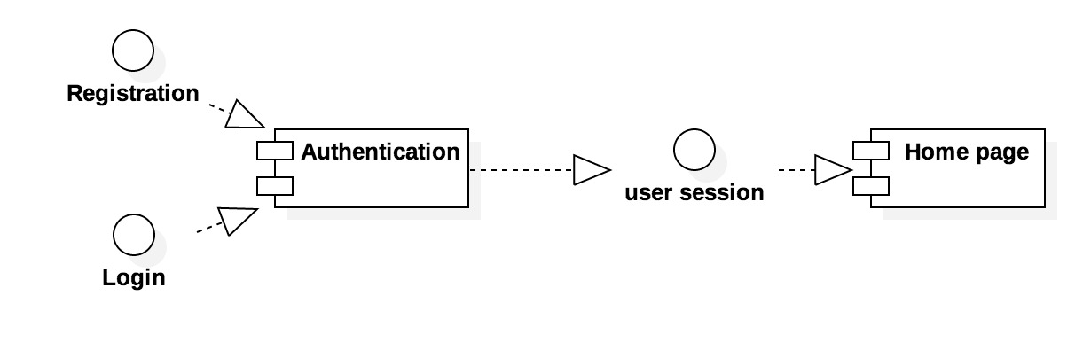

Login/Signup Component Diagram

1. **Component Name:** Display.

**Component Description:**

The Display component will be used to render the sensor data on the maps

**Component interfaces(internal and external):**

The Display function uses Google maps, on which it renders the data collected from the sensors.

External interfaces: The data is obtained through a web API, thus data has to be extracted from web API into the database.

**Responsible Development Team Member**  
Adarsh Bhandary and Varun Machingal are responsible for development of this component.

1. **Component Name:** Feedback

**Component Description:**

The Feedback component is another functionality provided to the user to post their feedback regarding the sensor data and their overall experience to help enhance the accuracy of the data, and attain future needs.

The feedback function will use POST method to send the feedback of the user to the admins. The admins will have access to the feedbacks.

**Responsible Development Team Member**  
Rahul Velayutham and Shantanu Kotambkar are responsible for development of this component.

1. **Component Name:** Generation of CSV file and Histograms.

**Component Description:**

The data received from the web API, will be stored in the database. This history of data, will then be used to generate Histograms and CSV format files of each sensor. This files and histogram can then be used to analysis the data at that sensor location and may be helpful in predicting future sensor locations.

**Responsible Development Team Member**  
Adarsh Bhandary and Shantanu Kotambkar are responsible for development of this component.

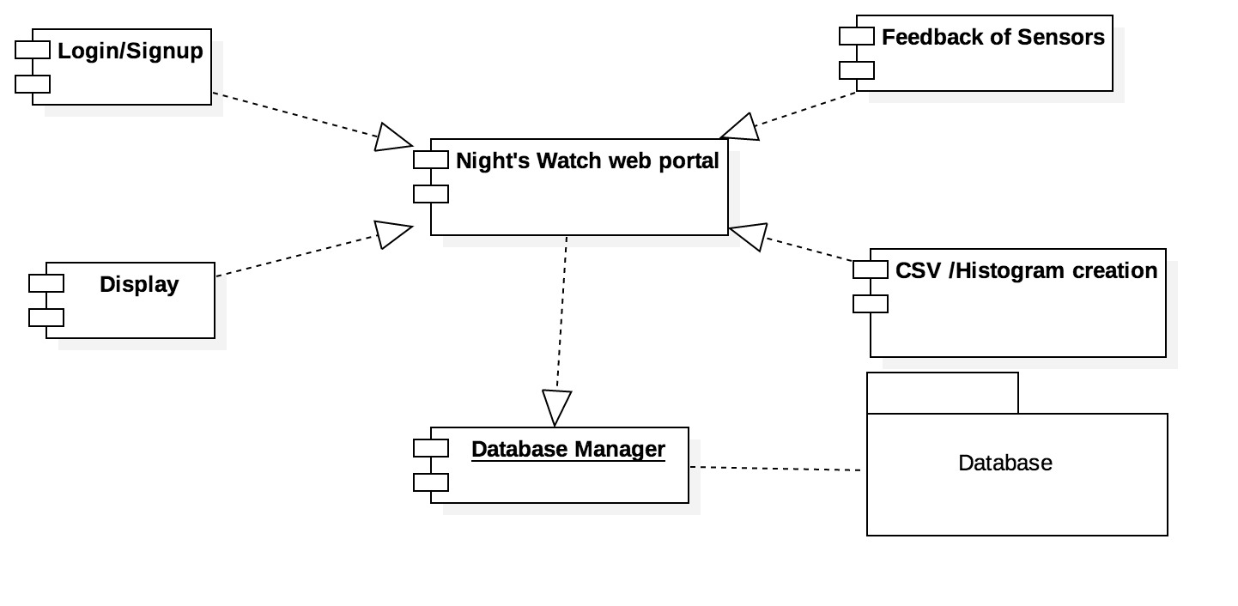

Component Diagram

**Revision History**

|  |  |  |
| --- | --- | --- |
| Revision | Date | Change Description |
| Sprint 1 | 10/01/2017 | Component : Login/Signup and sprint 1 module design. |
|  |  |  |
|  |  |  |
|  |  |  |
|  |  |  |
|  |  |  |

**Page Author:** Shantanu Kotambkar **Last Modified:** 10/01/2017